**INTRODUCTION**

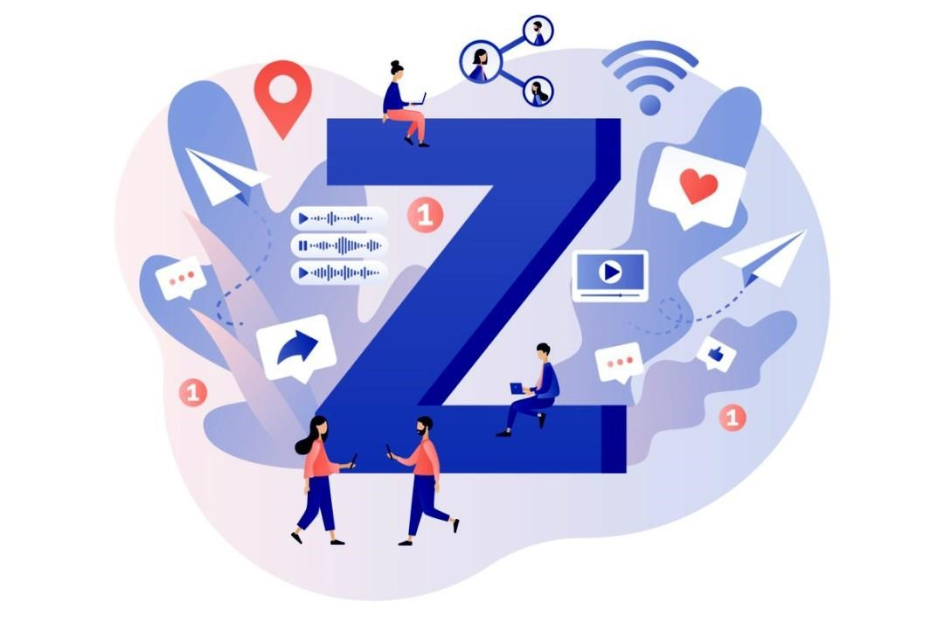

In the ever-evolving landscape of India, Generation Z, or Gen-Z, has emerged as a powerful force in shaping the nation’s workforce. This generation, born between the late 1990s and early 2010s, is particularly significant for India, home to the world’s largest Gen-Z population. Their choices and aspirations will undoubtedly have a substantial global impact on the future of work. This exploration delves into the unique characteristics of Gen-Z, their career ambitions, and the driving factors behind their choices. By understanding their dreams and challenges, we gain insight not only into their lives but also into the broader professional landscape.

The working generations refer to the various cohorts of people who are actively participating in the workforce at different periods in the history and different industrial revolutions. These generations are defined based on the different clusters of the year range in which these individuals were born and drive the technological experiences during their formative years and brings their unique perspective, values and work culture to the workplace. Below these are the main working generation

**What Is Happening**

In the modern world, aligning education with the evolving aspirations of Gen-Z is not just a choice; it’s a necessity. As one educator puts it, ‘To prepare Gen-Z for success, we must adapt to their changing career landscapes.

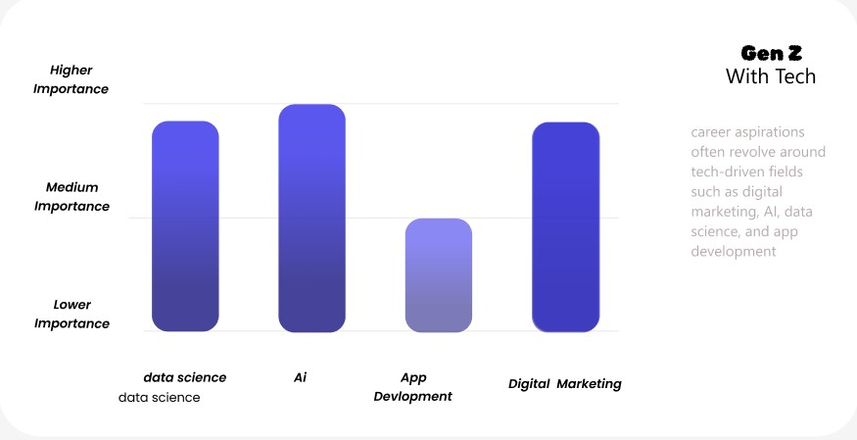

**Educational Evolution :** Gen-Z has grown up with technology, and their career aspirations often revolve around tech-driven fields such as digital marketing, AI, data science, and app development. Education systems need to emphasize digital literacy, coding, and other tech-related skills that align with these aspirations.

**Innovation and Entrepreneurship :** With the rise of the gig economy and freelance work, Gen-Z often aspires to be entrepreneurs. Schools and universities need to incorporate entrepreneurship into the curriculum, teaching students about business planning, marketing, and financial management.

**Who Is Impacted**

As we explore Gen-Z’s career aspirations, it’s crucial to consider the stakeholders affected by a lack of understanding regarding these aspirations, not just the Gen-Z aspirants themselves. Let’s identify who these key players are.



1. **Businesses**: Companies are profoundly impacted by the choices Gen-Z makes regarding their careers. Misinterpreting these aspirations can lead to challenges in talent acquisition, retention, and workforce diversity.
2. **Educational Institutions**: Schools and universities play a vital role in shaping Gen-Z’s perceptions of career opportunities. Understanding their aspirations can help educational institutions better align their curricula and career counseling services.
3. **Parents and Guardians**: Gen-Z individuals often seek guidance from their parents and guardians when making career decisions. Understanding their aspirations can aid parents in providing the right support and advice.

**Where Is This Happening**

This phenomenon isn’t limited to a specific location; it’s unfolding wherever Gen-Z individuals are actively pursuing their careers. The impact is particularly noticeable in workplaces, from traditional companies to innovative startups.

1. **Urban Areas:** In cities, Gen-Z often gravitates towards industries that thrive in high-density environments, such as technology, finance, media, and creative sectors. Urban settings provide the infrastructure and networking opportunities crucial for careers in these fields. The availability of coworking spaces, tech hubs, and entrepreneurial ecosystems supports their desire for innovation and collaboration.

1. **Rural Areas:** In contrast, career aspirations in rural areas might focus more on industries tied to local resources and needs, such as agriculture, manufacturing, and local services. With advancements in remote work and digital connectivity, some rural areas are witnessing a shift where Gen-Z individuals can pursue careers in technology, design, and digital marketing without being confined to urban centers. However, the infrastructure and access to professional development opportunities can be more limited. **Why Is This Happening**



Understanding Gen-Z’s career aspirations is more than a matter of financial success. It’s about the future of work, personal happiness, and innovation. With Gen-Z seeking purpose-driven jobs, prioritizing mental health, and advocating for fairness, they are reshaping the workplace landscape.

* 1. **Sustainability and Social Impact**: Gen-Z’s aspirations often align with causes related to sustainability and social impact. Acknowledging these values can lead to more responsible business practices and corporate social responsibility initiatives.
  2. **Diversity and Inclusion**: Gen-Z’s emphasis on diversity and inclusion can shape hiring practices, leading to more inclusive and equitable workplaces.
  3. **Collaborative Opportunities**: Understanding Gen-Z’s preferences for collaboration and flexible work arrangements can foster more dynamic and effective teamwork.

**WHEN**

Generation Z began entering the workforce around the early 2020s. They face a job market that is influenced by rapid technological advancements, economic shifts, and evolving workplace norms. This period is characterized by economic uncertainty and a transformation in traditional work structures.

1. **Rapid Technological Advancements** :The early 2020s have been marked by swift technological progress. Emerging technologies, such as artificial intelligence, machine learning, and automation, are reshaping industries and job roles. For Gen Z, who have grown up in a digital world, this tech-driven environment influences their expectations and working styles. They are accustomed to using advanced tools and platforms, which affects their preferences for tech-savvy work environments and innovative job roles.

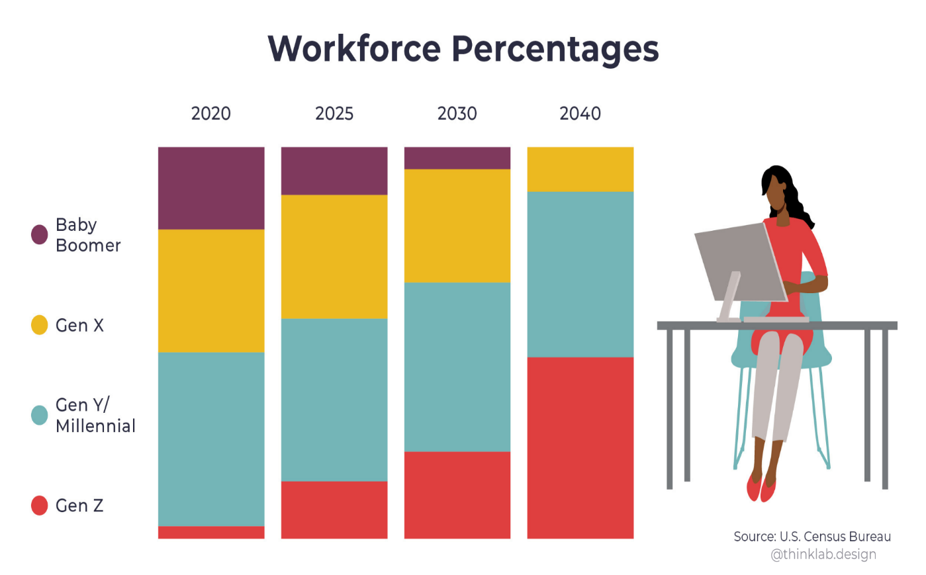

**2. Economic Shifts**: The global economy during the early 2020s has faced significant fluctuations. Events such as the COVID-19 pandemic led to widespread economic disruptions, including job losses, shifts in employment patterns, and changes in consumer behavior. These economic uncertainties impact job security and career prospects for Gen Z. They must navigate a job market that is less stable and more competitive, which influences their career planning and aspirations.

**Why**

The career aspirations of Gen Z are shaped by:

* **Technological advances:** Growing up with technology has influenced their work preferences and expectations.
* **Economic challenges:** The impact of economic instability and automation on job security.
* **Social values:** A strong emphasis on social responsibility and personal fulfillment.

**How**

To address these aspirations and challenges, several strategies can be employed:

**Educational alignment:** Ensure that educational programs align with current job market needs and provide practical skills.

**Workplace flexibility:** Adopt flexible work policies to meet the demands of Gen Z employees.

**Career development:** Provide clear paths for career advancement and continuous learning opportunities.

**Supportive environments:** Foster diverse and inclusive workplaces that reflect the values of Gen Z.

**CONCLUSION**

In conclusion, the journey of Gen-Z’s career aspirations is a collective endeavor that requires empathy, adaptability, and mutual support. By recognizing their unique needs and challenges, we can create a brighter future of work that benefits individuals, organizations, and society at large. This is a roadmap to understanding and supporting the dreams and aspirations of a generation poised to change the world.